SECTION 1: Identify and extract spending habits of customers by time-of-year (SQL)

SECTION 1:

The goal of this section is to find the item category that brings in the most revenue in order to allocate inventory space dependent on the time-of-year to maximize revenue for the upcoming year.

1. Download the reports from eBay.
2. View the reports in Excel.
   1. 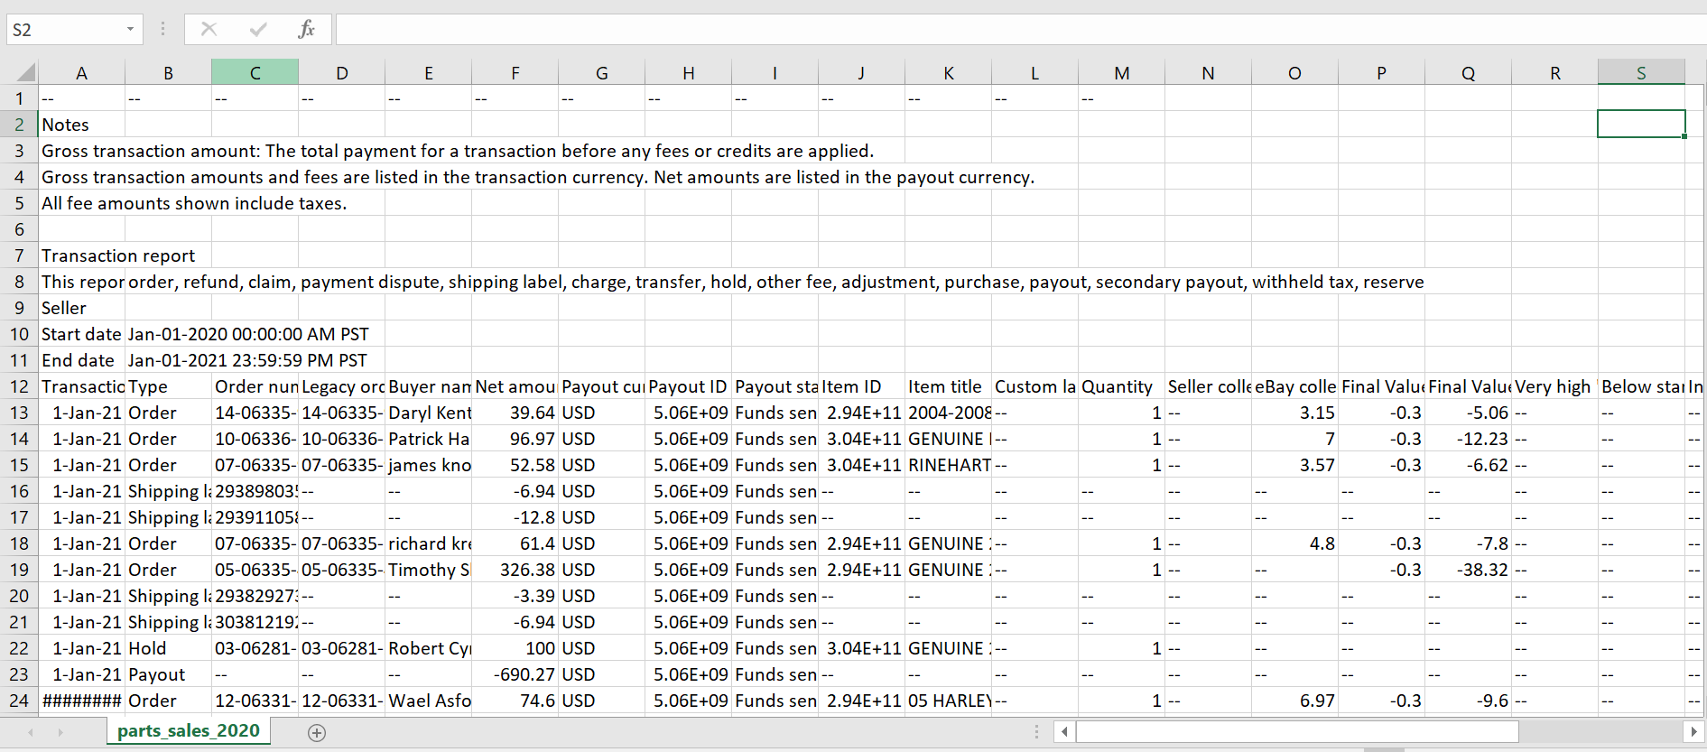
3. There are 6 types of transactions, but we only want to focus on “Order” and “Refund” when determining an item's performance. We used the Insert Table and Filter features to narrow our scope.
   1. 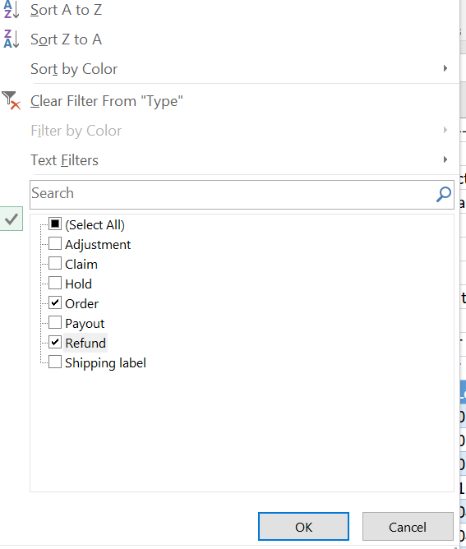
4. Let’s compare the number of returns we have with the number of orders. We used the PivotTable feature to quickly view the number of returned orders and the amount of money that was lost.
   1. 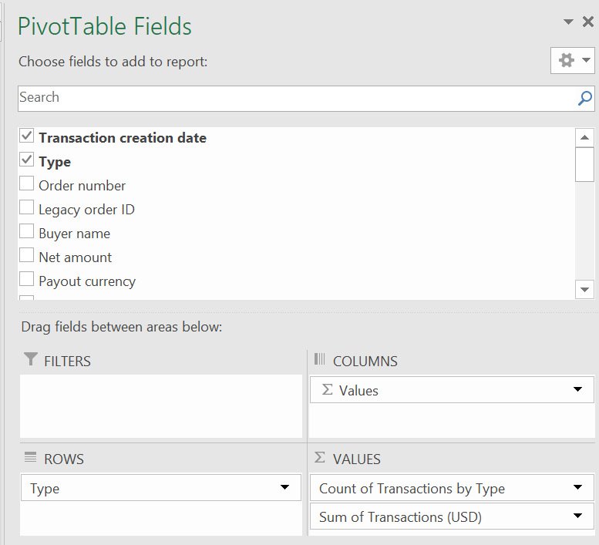
   2. 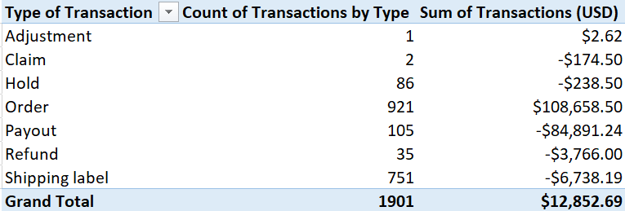
   3. 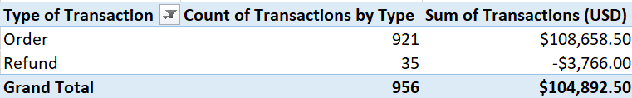
5. Let’s now import the data into SSMS for further analysis. We are filtering the transactions so that we are only focusing on orders that were placed.
   1. 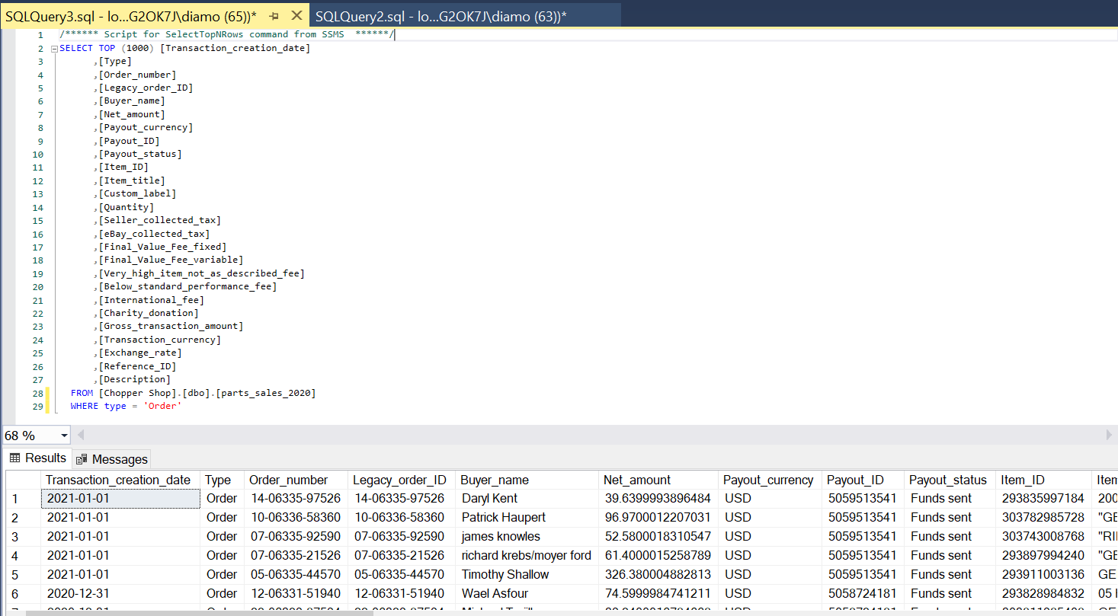
6. Let’s differentiate between car parts and motorcycle parts for each transaction. We will use the Case When function to help categorize items. For the cases, we are using common part names and popular motorcycle and car brands, respectively. Furthermore, we are using the CTE function to create a temporary table called “Orders” with only the date, part category, and the price fields to prepare our data for analysis in the next step.

| WITH Orders AS (  SELECT type AS "Transaction Type"  , transactions_2020.transaction_creation_date AS "Transaction Date"  , item_title AS "Item Name"  , FORMAT(gross_transaction_amount,'C') AS "Price"  , CASE  WHEN item_title LIKE '%harley%'  OR item_title LIKE '%indian%'  OR item_title LIKE '%touring%'  OR item_title LIKE '%honda%'  OR item_title LIKE '%rod%'  OR item_title LIKE '%memphis%'  OR item_title LIKE '%kawasaki%'  OR item_title LIKE '%yamaha%'  OR item_title LIKE '%dyna%'  THEN 'Bike'  WHEN item_title LIKE '%astro%'  OR item_title LIKE '%porsche%'  OR item_title LIKE '%benz%'  OR item_title LIKE '%chrysler%'  OR item_title LIKE '%chevy%'  OR item_title LIKE '%ford%'  OR item_title LIKE '%jaguar%'  OR item_title LIKE '%cayenne%'  OR item_title LIKE '%infiniti%'  OR item_title LIKE '%van%'  OR item_title LIKE '%audi%'  OR item_title LIKE '%bmw%'  OR item_title LIKE '%buick%'  OR item_title LIKE '%jeep%'  OR item_title LIKE '%foose%'  THEN 'Car'  ELSE 'Uncategorized'  END AS 'Part Category'  FROM [Chopper Shop].[dbo].[parts_sales_2020] transactions_2020  WHERE type = 'Order'  AND Gross_transaction_amount IS NOT NULL  AND item_title != '--'  )  SELECT "Transaction Date"  ,"Part Category"  , Price  FROM Orders |
| --- |

1. 